Visual Composition
Assignment 3
Outcome: How typography relates to the use of text in a visual message

Task: Find a quotable quote, 7 words or more, and construct the text in a unique shape, preferably in a shape that reflects the theme of the quote. For example, if the quote mentions butterflies, put the message in the shape of a butterfly.
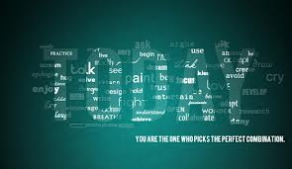
From: http://www.wall321.com/Art_Design/Typography/minimalistic_typography_artwork_1920x1111_wallpaper_82721
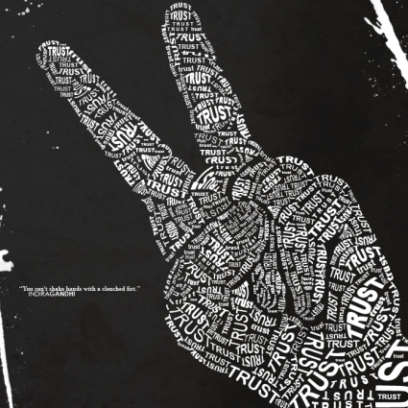 http://designm.ag/images/0609/textart/14.jpg+

